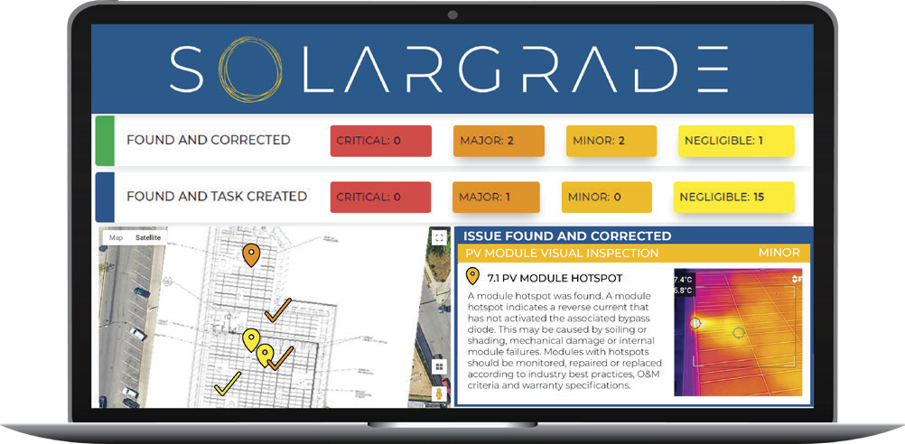
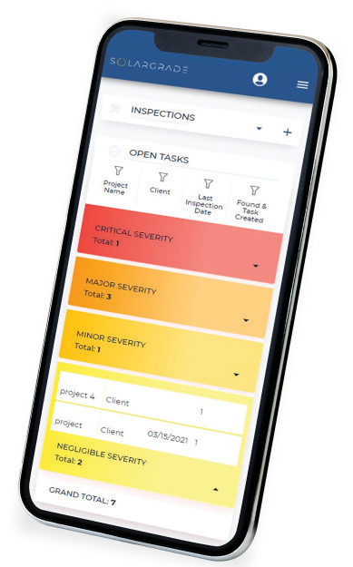
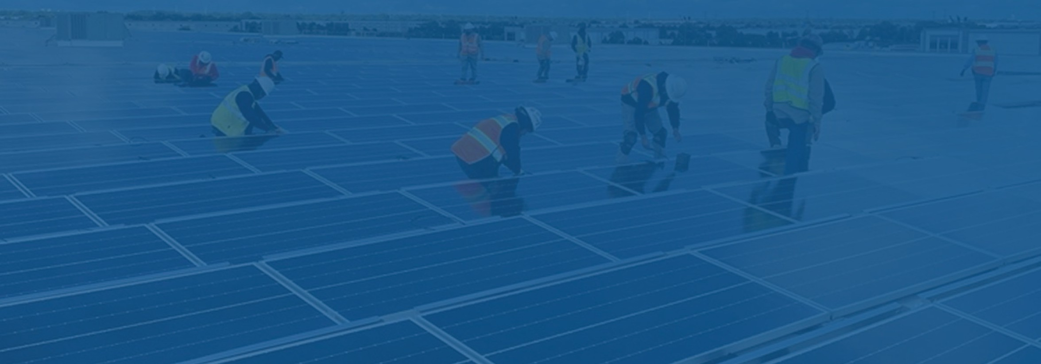
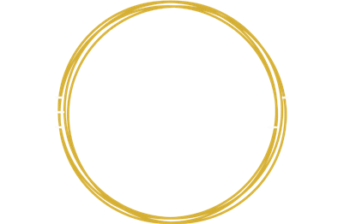
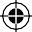
THE HELIOVOLTA ADVANTAGE

INTRODUCING HELIOVOLTA
We provide third-party QA/QC and technical field services to help renewable energy and storage stakeholders achieve both system safety and reliability through project lifecycles.
7+ GWs of project experience 50+ years of industry experience 500+ projects inspected

NABCEP-certified PV system inspectors

SolarGrade fieldwork management software

HelioVolta developed SolarGrade, the fieldwork management software for faster, more accurate asset inspections and reports.


Our Independent Inspections and Technical Services

QA/QC and System Audits
Third-Party Health Assessments
Audits asset health and identifies risks before failure.
Construction QA/QC
Ensures best practices at installation. Post-Commissioning Inspections Validates system operates to design;
creates punch lists.
End of EPC Warranty Inspections
Identifies outstanding workmanship issues.

Technical Services
Failure Root Cause Analysis
Diagnoses of underlying issues when systems have thermal events or underperform.
Technical Advisory Support
Establishes construction and O&M quality standards. Informs technical decisions and due diligence for investors and other project stakeholders.
Ready to learn more?
Contact us at info@heliovolta.com



ABOUT SOLARGRADE

The cloud-based platform for smarter, faster renewable energy
fieldwork and asset management.


SolarGrade empowers teams to operate safe, reliable, and high-performing renewable assets — at scale, on time, and on budget.

 Be 30% more efficient in the field
Increase production with more uptime
Prevent safety events with standardized QA/QC  Elevate asset care with better data



SolarFaxTM and SolarTwinTM are data analytics tools within the SolarGrade platform.
KEY FEATURES
- Georeferenced issue tagging
- Mobile photo capture and editing
- Pre-built, pre-loaded inspection protocols (customizable)
- Pre-written, pre-loaded issue descriptions (editable)
- Integrated as-builts with mark- up tools
- Automated reporting and punch lists
- Split up and assign tasks in the
field, even off-line

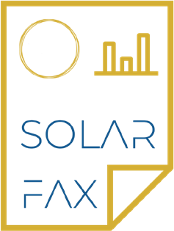
SolarFaxTM is a data analytics module that pairs system-level energy yield and performance
data with SolarGrade health
assessments.
SolarFaxTM reports provide a complete view of PV system health, safety, performance, and reliability.

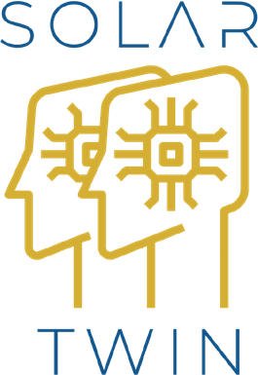
SolarTwinTM utilizes data from SolarFaxTM and SolarGrade to generate digital representations of physical PV assets.
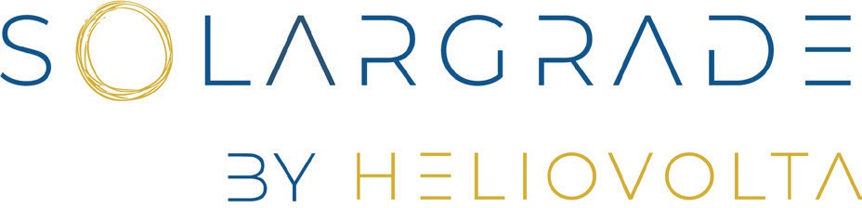
This digital twin allows users to have a clearer picture of PV
assets to drive more productive and reliable assets.

